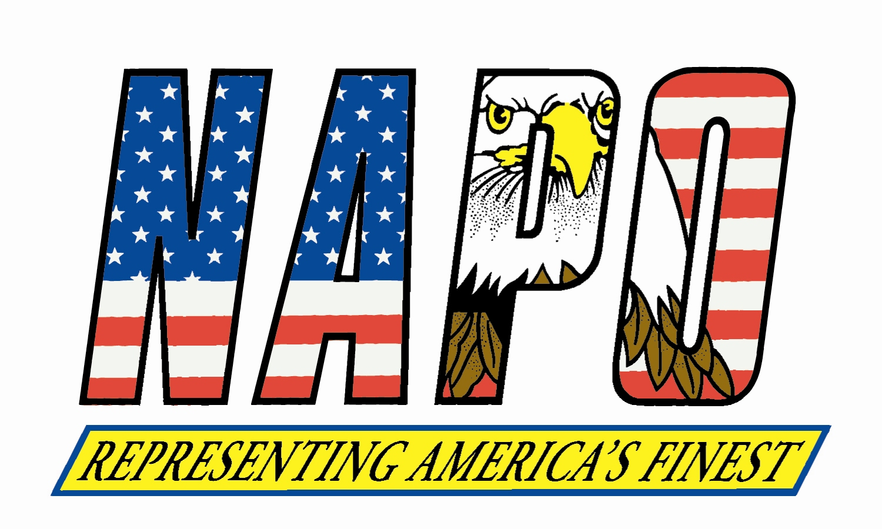
January 8, 2014
317 South Patrick Street. ~ Alexandria, Virginia ~ 22314-3501

(703) 549-0775 ~ (800) 322-NAPO ~ Fax: (703) 684-0515

www.napo.org ~ Email: info@napo.org

317 South Patrick Street. ~ Alexandria, Virginia ~ 22314-3501

(703) 549-0775 ~ (800) 322-NAPO ~ Fax: (703) 684-0515

www.napo.org ~ Email: info@napo.org

Executive Officers

Thomas J. Nee
President
Boston Police
Patrolmen’s Association

MICHAEL McHALE
Executive Vice President
Florida Police Benevolent
Association

CHRIS COLLINS
Recording Secretary
Las Vegas Police
Protective Association

Sean M. Smoot
Treasurer
Police Benevolent & Protective
Association of Illinois

KEITH DUNN
Sergeant-at-Arms
New Jersey State Policemen’s
Benevolent Association

JOHN A. FLYNN
Executive Secretary
Patrolmen’s Benevolent
Association of New York City

William J. Johnson
Executive Director
NATIONAL ASSOCIATION OF POLICE ORGANIZATIONS, INC.
Representing America’s Finest
Executive Officers

Thomas J. Nee
President
Boston Police
Patrolmen’s Association

Michael MCHALE
Executive Vice President
Florida Police Benevolent
Association

CHRIS COLLINS
Recording Secretary
Las Vegas Police
Protective Association

Sean M. Smoot
Treasurer
Police Benevolent & Protective
Association of Illinois

KEITH DUNN
Sergeant-at-Arms
New Jersey State Policemen’s
Benevolent Association

JOHN A. FLYNN
Executive Secretary
Patrolmen’s Benevolent
Association of New York City

national headquarters

William J. Johnson
Executive Director
NATIONAL ASSOCIATION OF POLICE ORGANIZATIONS, INC.
Representing America’s Finest

The President of the United States
The White House
Washington, D.C. 20500

Dear President Obama:

On behalf of the National Association of Police Organizations (NAPO), I am writing to express our strongest possible opposition to the nomination of Debo Adegbile to be the next Assistant Attorney General for the Civil Rights Division at the U.S. Department of Justice (DOJ).

NAPO is a coalition of police unions and associations from across the United States that represents more than 1,000 police units and associations, 241,000 sworn law enforcement officers, and more than 100,000 citizens who share a common dedication to fair and effective crime control and law enforcement.

NAPO is deeply concerned that under Mr. Adegbile’s leadership, the Legal Defense Fund of the National Association for the Advancement of Colored People volunteered their services to defend Mumia Abu-Jamal, a convicted cop-killer. Abu-Jamal was convicted of murdering Philadelphia Police Officer Daniel Faulkner in 1982. Mr. Adegbile worked tirelessly to free this unrepentant cop-killer. The nominee’s efforts led to the overturning of the just sentence Abu-Jamal received for murdering a valuable member of the law enforcement community.

NAPO firmly believes Mr. Adegbile’s history makes him an inappropriate choice to lead DOJ’s Civil Rights Division, and we vehemently oppose this nomination. We urge you to reconsider the nomination, as Mr. Adegbile has not shown respect for members of law enforcement who put their lives on the line everyday to keep our nation safe.

If NAPO can provide any additional information, please feel free to contact me at: (703) 549-0775.

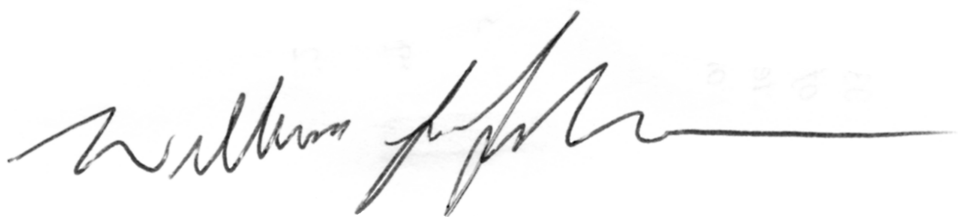
Sincerely,

William J. Johnson
Executive Director

cc: The Vice President
The Attorney General
Hon. Patrick Leahy, Chairman, Senate Judiciary Committee
Hon. Chuck Grassley, Ranking Member, Senate Judiciary Committee

