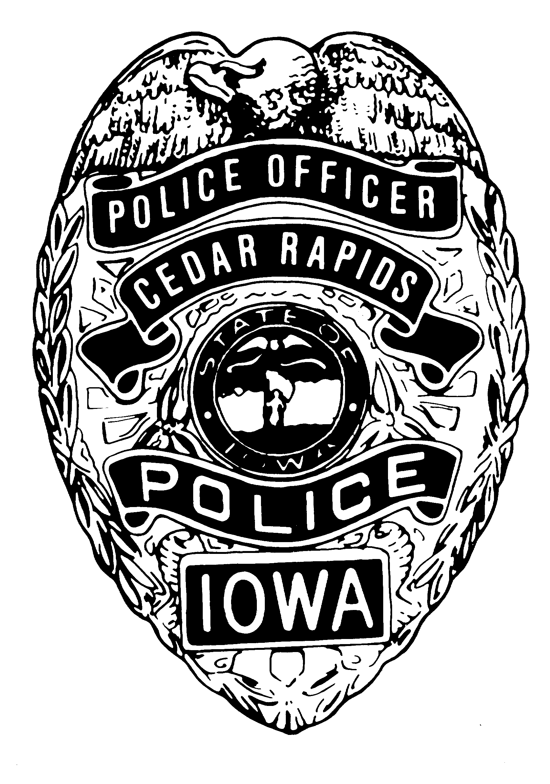CEDAR RAPIDS POLICE 2014 CALENDAR
ORDER YOUR CALENDAR TODAY!

The Cedar Rapids Police Department is excited to announce the sale of our 2014 CRPD Calendar! The calendar contains monthly photos of officers and specialties within our department. They include Honor Guard, SRT, Bomb Squad, Crime Scene Unit, Training Division, and much more! The month of May is dedicated to remembering the six officers who died in the line of duty in our CRPD history.

The funds raised from the sale of the calendars will be used by the CRPD Honor Guard to send officers each May to the National Law Enforcement Week in DC. In 2013, an estimated 30,000 officers nationwide attended to pay respect to the fallen officers and their families. Attending the Law Enforcement Week provides the opportunity for us to represent the Cedar Rapids Police Department and the city of Cedar Rapids.

These unique 8” X 11” calendars make a great Christmas gift for your friends, family, or yourself! Whether you are a Cedar Rapids area residence, or a current or retired law enforcement officer, order yours TODAY so you have it before Christmas and 2014!

The backside of this letter contains an order form. Thank you and enjoy your 2014 Cedar Rapids Police Department Calendar! Any questions please contact:

CRPD Sgt. Brian Been 319-286-5541
b.been@cedar-rapids.org

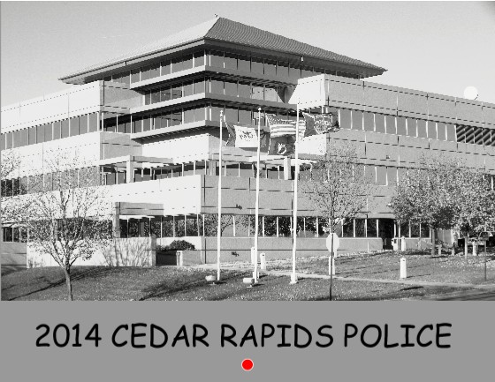

CRPD 2014 POLICE CALENDAR
ORDER FORM

YOUR NAME: ____________________________________

YOUR CONTACT PHONE: ___________________________

ADDRESS TO DELIVER CALENDAR: ____________________________________________________________

____________________________________________________________

BEST DATE/TIME TO DELIVER CALENDAR IN PERSON (UNLESS OTHERWISE REQUESTED):_________________________________________________

____________________________________________________________

CALENDAR PRICE: $12 EACH

NUMBER OF CALENDARS PURCHASING: _____________

AMOUNT OF MONEY ENCLOSED: _____________

PAYMENT CAN BE MADE WITH CASH OR CHECK. (CASH-REQUEST EXACT AMOUNT.THANK YOU)!

MAKE CHECK TO: CRPD HONOR GUARD, ATTN: 2014 CRPD CALENDAR

ORDER FORM/PAYMENT CAN BE EITHER DROPPED OFF IN PERSON AT THE POLICE DEPARTMENT OR MAILED TO:

CEDAR RAPIDS POLICE
C/O HONOR GUARD
505 1ST ST SW
CEDAR RAPIDS, IA 52404

THANK YOU FOR YOUR SUPPORT AND ENJOY YOUR 2014 CRPD CALENDAR!

Paid:_________ Delivered:__________

