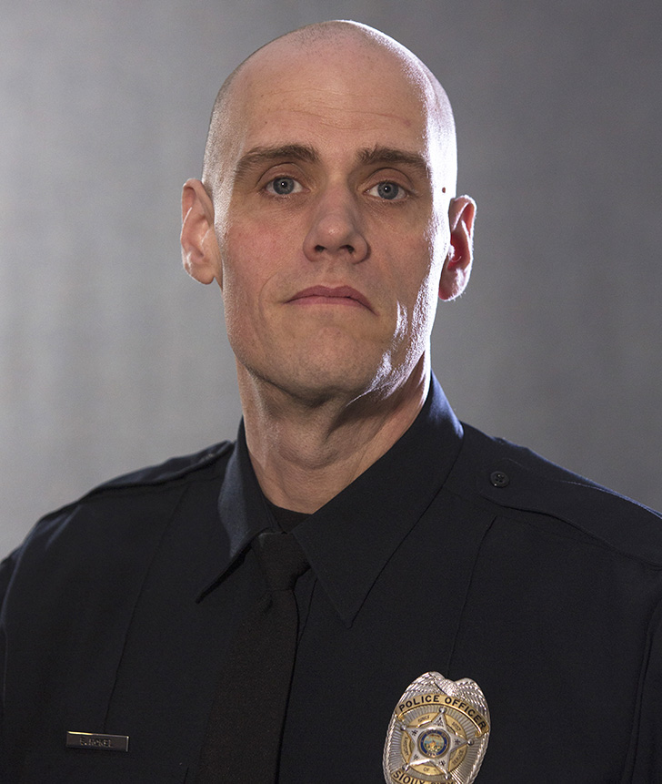
RAFFLE DRAWING
To BENEFIT

Officer Bruce Hokel

Officer Bruce Hokel has been with the Sioux City Police Department for 13 ½ years. In January 2019 Bruce sustained a severe injury to his lower left leg while helping a retired officer repair a roof.
The surgery to repair Bruce’s injury caused many months of complications and infection. This ultimately led to Bruce having his left leg amputated below the knee in April 2019. This was in an effort to save the rest of his leg and possibly his life.
Bruce is the father of 3 children and 2 step children. Due to past medical issues with Bruce’s family he has exhausted his paid time off. He is currently on unpaid leave and his medical bills are mounting. While Bruce fully intends to return to work once fitted with a prosthetic leg, we are asking you to help support Bruce and his family during his rehabilitation.

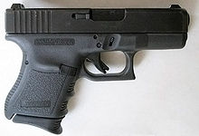
Drawing will be
June 5th, 2019 @ 7:00 PM
(You will not receive raffle tickets; the ticket numbers will be emailed to you)
- must be able to legally own a firearm
- need not be present to win

TOP PRIZE GLOCK- winner will receive a $350 certificate for small frame GLOCK of their choice (limited selection)
RAFFLE TICKETS
1 for $10.00
7 for $50.00
15 for $100.00

Additional Prizes
(to be announced) will also be awarded to raffle winners

- - - - - - - - - - - - - - - - - - - - - - - - Detach - - - - - - - - - - - - - - - - - - - - - - -
Your name__________________________ Amount $_________________________
Address____________________________ # of tickets bought__________________
City/State/Zip_______________________
Email______________________________ Ques?: Please contact Ofc Brooke Davies
Contact Ph number___________________ Bdavies@sioux-city.org or 712-899-5784

